DAX:

* Data Analysis Expressions
* Create new information
* Create new information
* Period to Period comparison
* Modify model when you can't modify data source

**Aggregate Function:**

Sum

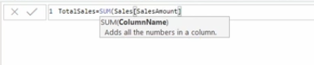

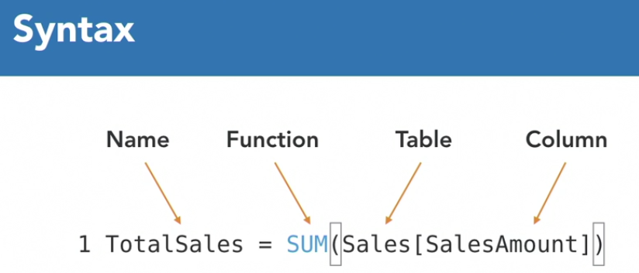

Count

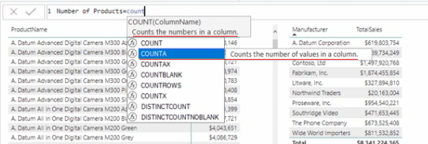

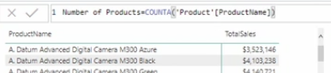

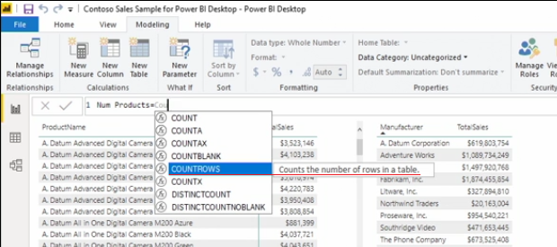

Count Rows

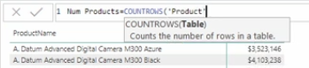

Comment

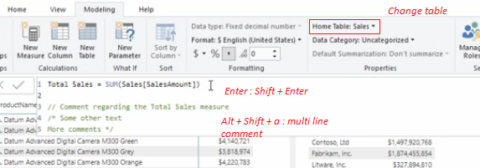

Count Blank

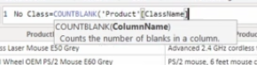

Distinct Count

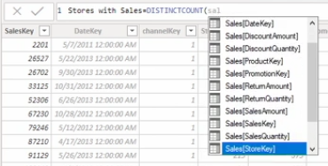

**Measures and Calculated Columns**

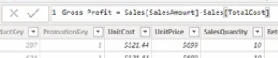

calculated column stored in the table

measure calculated in RAM

**Explicit and Implicit measures**

measure created by adding value/measure to visualization- implicit measure, can not format or reuse

formatted measure, same meaning can be used again and again - create explicit measure

**Measure with operator**

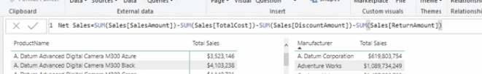

Create measure with Divide

handle divide by zero

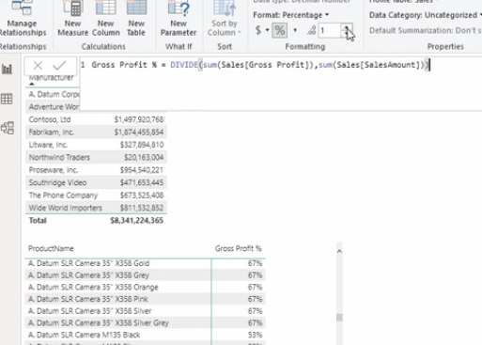

SUMX - iterator

moves row by row through table, does a calculation/retrieve data, perform aggregation in the end.

Same as calculated column

sumx, countx, minx, maxx, averagex, rankx

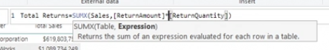

DAX Date / Time function

Day, month, year(date)

hour, minute, second(time)

weekday, weeknum(date)

datediff (start date, end date, date interval)

eom (start date, months +/-)

Today, Now

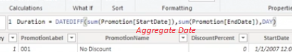

**DAX Logical and Filter Function**

FIND - find substring within a string

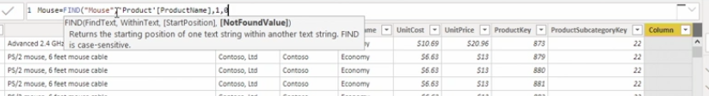

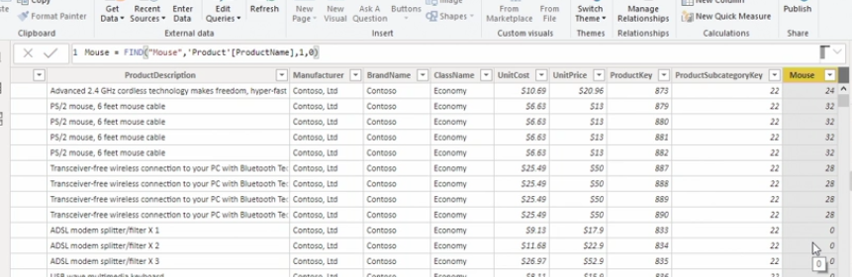

IF

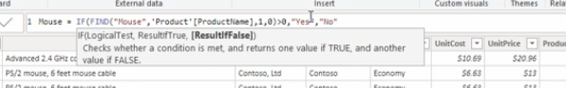

OR - to handle case sensitivity

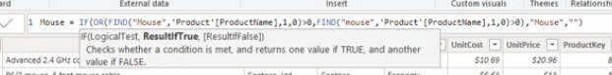

CALCULATE - to create simple filter

